Celebrant: Rev. Nicholas A. Sannella

Gathering Hymn – Table of Plenty

First Reading

Isaiah (35:1-10) A Reading from the Book of the Prophet Isaiah

The desert and the parched land will exult; the steppe will rejoice and bloom. They will bloom with abundant flowers, and rejoice with joyful song. The glory of Lebanon will be given to them, the splendor of Carmel and Sharon; they will see the glory of the Lord, the splendor of our God. Strengthen the hands that are feeble, make firm the knees that are weak, say to those whose hearts are frightened: Be strong, fear not! Here is your God, he comes with vindication; with divine recompense he comes to save you.
Then will the eyes of the blind be opened, the ears of the deaf be cleared. Then will the lame leap like a stag, then the tongue of the dumb will sing. Streams will burst forth in the desert, and rivers in the steppe. The burning sands will become pools, and the thirsty ground, springs of water; the abode where jackals lurk will be a marsh for the reed and papyrus. A highway will be there, called the holy way; no one unclean may pass over it, nor fools go astray on it. No lion will be there, nor beast of prey go up to be met upon it. It is for those with a journey to make, and on it the redeemed will walk. Those whom the Lord has ransomed will return and enter Zion singing, crowned with everlasting joy. They will meet with joy and gladness; sorrow and mourning will flee.

The Word of the Lord.

Thanks be to God.

Responsorial Psalm – The Lord is my Light

Second Reading

Apostles (4:8-12) A reading from the Acts of the Apostles

Peter, filled with the Holy Spirit, spoke up: “Leaders of the people! Elders! If we must answer today for a good deed done to a cripple and explain how he was restored to health, then you and all the people of Israel must realize that it was done in the name of Jesus Christ the Nazorean whom you crucified and whom God raised from the dead. In the power of that name this man stands before you perfectly sound. This Jesus is 'the stone rejected by you the builders which has become the cornerstone.' There is no salvation in anyone else, for there is no other name in the whole world given to men by which we are to be saved."

The Word of the Lord.

Thanks be to God.

Gospel

John (5:1-9)

After this, there was a feast of the Jews, and Jesus went up to Jerusalem. Now there is in Jerusalem at the Sheep (Gate) a pool called in Hebrew Bethesda, with five porticoes. In these lay a large number of ill, blind, lame, and crippled. One man was there who had been ill for thirty-eight years. When Jesus saw him lying there and knew that he had been ill for a long time, he said to him, "Do you want to be well?" The sick man answered him, "Sir, I have no one to put me into the pool when the water is stirred up; while I am on my way, someone else gets down there before me." Jesus said to him, "Rise, take up your mat, and walk." Immediately the man became well, took up his mat, and walked.

The Gospel of the Lord.

Praise to you, Lord Jesus Christ
Homily

Prayers of the Faithful

Offertory – Send Us Your Spirit

Communion – Christ, Be Our Light

The Most Powerful Healing Prayer by St. Padre Pio

Closing – Take the Word of God With You

Anointing of the Sick Sacrament

Mass of Healing

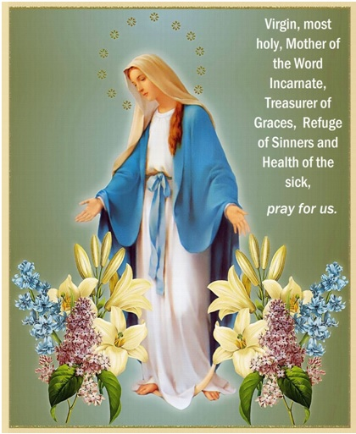

IMMACULATE CONCEPTION CHURCH
144 East Merrimack Street
Lowell, MA

